**Name: Nguyen Xuan Binh**

**Student ID: 887799**

**Fracture Mechanics Assignment 4**

According to the formula in the datasheet:

 (answer)

The polymer plate is thin => The plane stress condition is assumed

Therefore, the plastic zone size:



If the plastic zone size  is roughly an order of magnitude smaller than the crack length (), we conclude that LEFM applies, and fracture will occur when . Since , LEFM can be applied here.

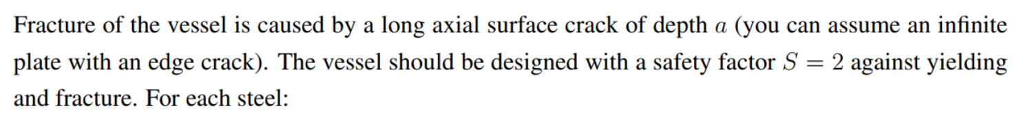

The formulas belong to the thin-wall version, which means we assume plane stress state.

Because we assume an infinite plate with an edge crack, the formula from datasheet is

, where safety factor is taken into account

* The maximum permissible pressure p as a function of crack depth a is
*  The maximum permissible pressure a is 

Because we assume a plane stress condition, the longitudinal stress is along the vessel surface. Thus, the von Mises criterion yielding stress becomes

, where

(hoop stress), (longitudinal stress) and 

* 
* 
* . Yielding occurs when 

The Matlab code:

% radius and thickness (m)

R = 1;

t = 0.04;

% Safety factor

S = 2;

% Steel A 4340

A_sigmaY = 860;

A_Kic = 100;

% Steel B 4335

B_sigmaY = 1300;

B_Kic = 70;

% Steel C 350

C_sigmaY3 = 1550;

C_Kic = 55;

% Define the range of crack depths

a = 0:0.1:30; % Assume crack depth values from 0 to 10 with a step of 0.1

% Calculate the maximum permissible pressure

pA = A_Kic * (t./(1.12 * S * R * sqrt(pi * a)));

pB = B_Kic * (t./(1.12 * S * R * sqrt(pi * a)));

pC = C_Kic * (t./(1.12 * S * R * sqrt(pi * a)));

% Plot the maximum permissible pressure as a function of crack depth

plot(a, pA, 'r-', 'LineWidth', 2);

hold on;

grid on;

plot(a, pB, 'b-', 'LineWidth', 2);

plot(a, pC, 'g-', 'LineWidth', 2);

legend('Steel A 4340', 'Steel B 4335', 'Steel C 350');

xlabel('Crack Depth (a) [mm]');

ylabel('Maximum Permissible Pressure (p) [MPa]');

title('Maximum Permissible Pressure vs. Crack Depth');

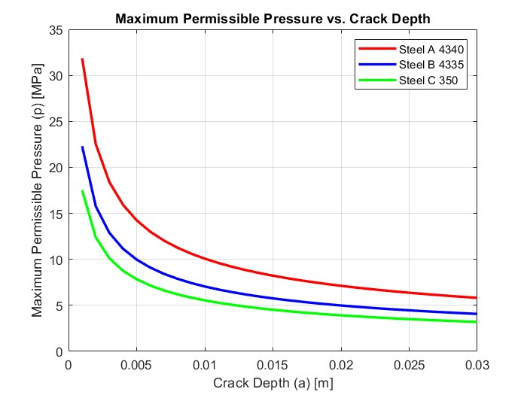

First, we need to check if the operating pressure will cause yielding stress larger than the material yielding stress



This yield stress is smaller than the material yielding stress for all three materials, so any steel can be used for this design. Now we can plug in the formula for maximum permissible crack depth a:

% Maximum permissible crack depth when p = 12MPa

p_op = 12;

aA = ((A_Kic * t)./(p_op * 1.12 * S * R * sqrt(pi)))^2 * 10 ^ 3;

disp(aA)

aB = ((B_Kic * t)./(p_op * 1.12 * S * R * sqrt(pi)))^2 * 10 ^ 3;

disp(aB)

aC = ((C_Kic * t)./(p_op * 1.12 * S * R * sqrt(pi)))^2 * 10 ^ 3;

disp(aC)

Steel A 4340: 7.04mm (answer)

Steel B 4335: 3.45mm (answer)

Steel C 350: 2.13mm (answer)

First, we need to calculate the maximum pressure according to critical stress intensity factor:

%%%%%% pressure at a = 1mm according to KIc

a = 0.001;

pA = A_Kic * (t/(1.12 * S * R * sqrt(pi * a)));

pB = B_Kic * (t/(1.12 * S * R * sqrt(pi * a)));

pC = C_Kic * (t/(1.12 * S * R * sqrt(pi * a)));

disp(pA)

disp(pB)

disp(pC)

Steel A 4340: 31.9 MPa

Steel B 4335: 22.3 MPa

Steel C 350: 17.5 MPa

Next, we need to calculate the maximum pressure according to yield stress

%%%%%% maximum pressure according to yield stress

pA = (2 * t * A_sigmaY)/(S * R * sqrt(3));

pB = (2 * t * B_sigmaY)/(S * R * sqrt(3));

pC = (2 * t * C_sigmaY)/(S * R * sqrt(3));

disp(pA)

disp(pB)

disp(pC)

Steel A 4340: 19.9 MPa

Steel B 4335: 30.0 MPa

Steel C 350: 35.8 MPa

Therefore, the failure pressure p for the 1mm crack depth is the minimum of the two pressures derived from the two criteria

Steel A 4340: 19.9 MPa (answer)

Steel B 4335: 22.3 MPa (answer)

Steel C 350: 17.5 MPa (answer)

First, the top and bottom faces are rigidly clamped, so there won’t be deformation normal to the deformation plane => Plane strain condition is assumed. Additionally, the material is linear elastic, so it means J = G (energy release rate).

The definition of the J integral is:

 and the contour can be divided in five segments as:



Let’s define x and y in the horizontal and vertical directions, respectively. Along segments AB and CD, we have no variations in y and the displacement field will be constant with x so:

 and  => 

Along segments AA’ and DD’, we have no stress, and the contour is vertical, therefore:

 and  => 

Consequently, 

 since there is only shear stress

*  where G is the shear modulus
* , the shear strain is 
* , since  for isotropic materials